**ECS – TASK**

1. **Setup a highly available ecs cluster with load balancer and dynamic port mapping.**

**Architecture & decisions (quick)**

* 3 AZs for HA (one subnet per AZ)
* ALB in public subnets (internet facing)
* Fargate tasks in private subnets (recommended) — tasks do not have public IPs; ALB talks to tasks via private IPs and dynamic ports.
  + Option B (simpler for testing): put tasks in public subnets with assign_public_ip = true. (Not recommended for prod.)
* Use target_type = "ip" in the Target Group (required for Fargate + dynamic ports).
* Container definitions should specify containerPort but omit hostPort so ECS uses dynamic host ports.

**High-level steps**

1. Create VPC + subnets (public + private), IGW, NAT Gateway (for private subnets’ egress).
2. Create Security Groups (ALB SG + tasks SG).
3. Create ALB, Target Group (target_type = "ip"), and Listener.
4. Create IAM roles (task execution role + task role).
5. Create CloudWatch Log Group.
6. Create ECS Cluster.
7. Create ECS Task Definition (FARGATE) with container definitions using dynamic port mapping.
8. Create ECS Service referencing ALB target group (load_balancer block) and network_configuration referencing private subnets.
9. (Optional) App autoscaling and outputs.
10. Validate and debug.

**In main.tf I have written a code**

[**https://github.com/Shaik123-hu/ECS-Project.git**](https://github.com/Shaik123-hu/ECS-Project.git)

**this will create the a highly available ecs cluster with load balancer**

**create a folder**

**open visual studio**

**aws configure**

**terraform init**

**terraform plan**

**terraform apply**

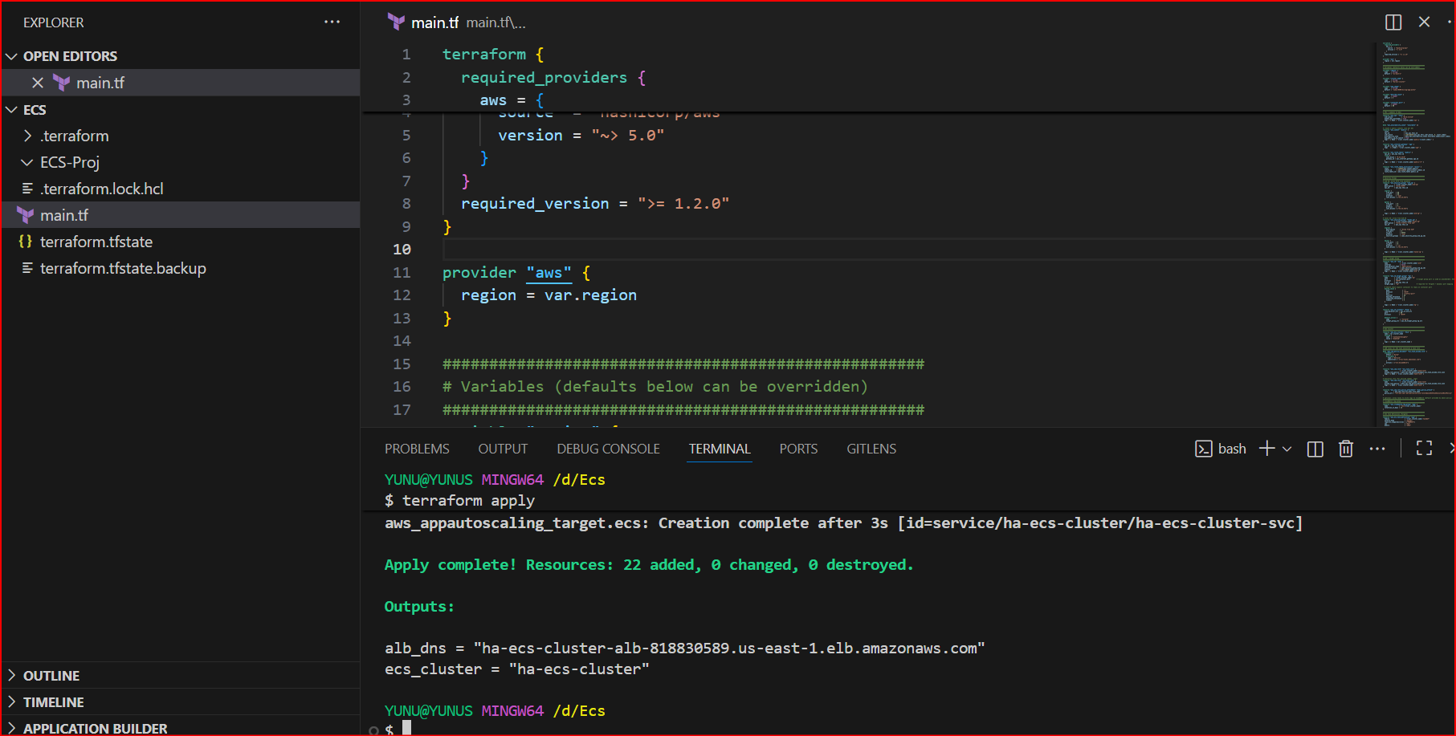

**Once this is done check in aws console**

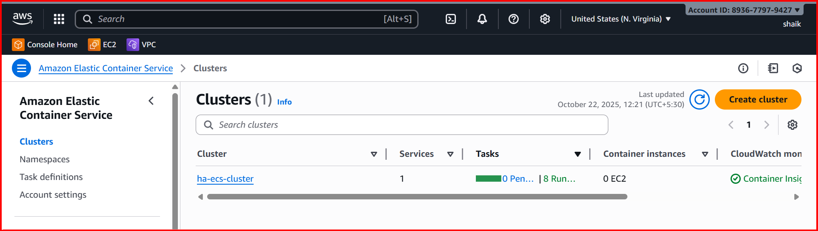

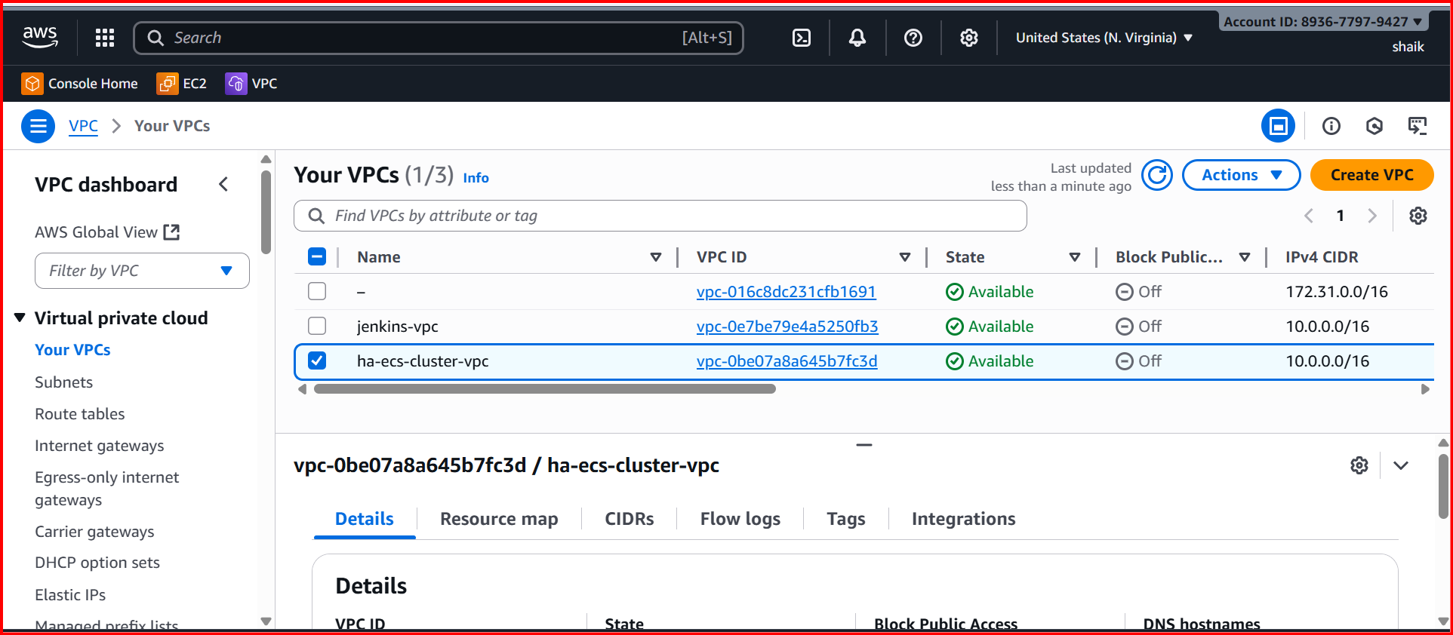

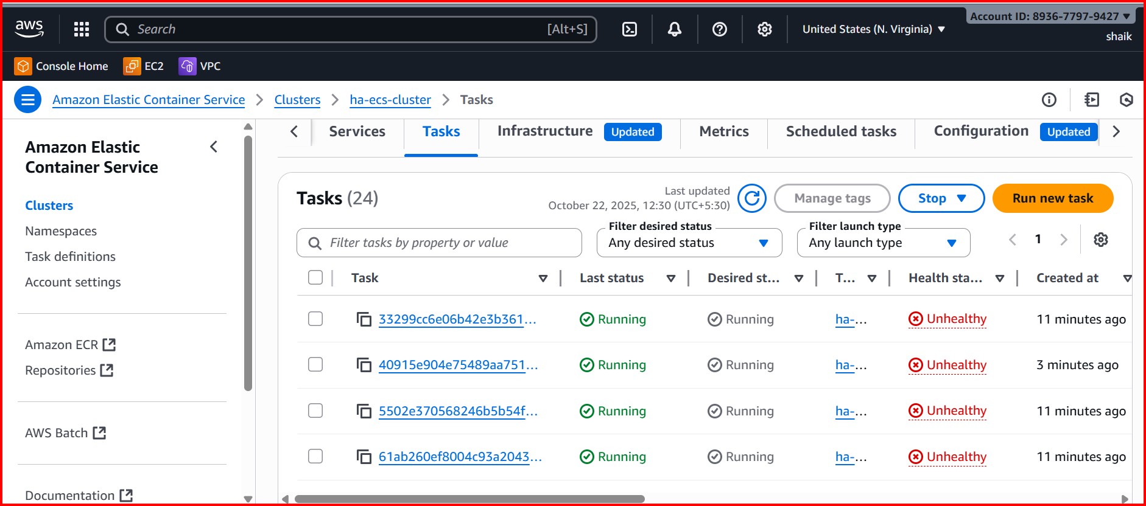

**Go to load balancer**

**And check with DNS**

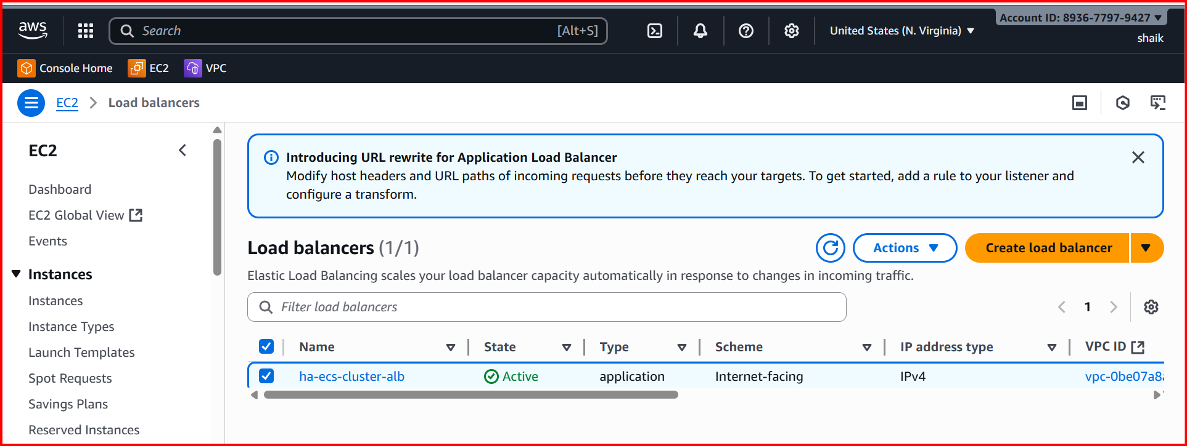

**ha-ecs-cluster-alb-818830589.us-east-1.elb.amazonaws.com**

